Results HCA: Our performance management system
About Results HCA
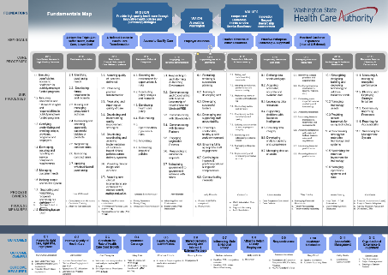
Results HCA is how we measure our performance. We measure performance at the agency level, as well as at each division level. We have several tools that help us manage the system: The fundamentals map
Our agency fundamentals map shows our mission, vision, values, key goals, outcome measures, and routine work. It is a process view of our work, not an organization chart.
Much like Gov. Jay Inslee's Results Washington initiative (http://www.results.wa.gov/), Results HCA helps us track and measure progress in key areas of our work. Through Results HCA, we use data to celebrate our successes and plan for improvement where needed.
(For more information, read the article, Why performance measures matter, by PW Ingraham, PG Joyce, and AK Donahue. https://books.google.com/books?hl=en&lr=&id=6tdYJsFzfzIC)
Quarterly Target Reviews
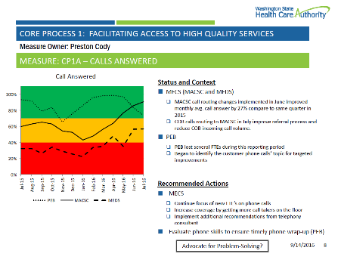
Quarterly meetings to review the performance of our agency measures. There is an agency-level Quarterly Target Review (QTR), attended by Extended Management Team, and then division-level QTRs.
The QTRs:
> Are a frequent reminder of what is most important (up, down and across the organization).
> Reinforce accountability and the importance of taking effective action.
> Make performance visible in a safe environment.
> Enable people involved to share the joy of accomplishment.
> Instill confidence and hope.
> Keep everyone focused on results and outcomes, not just activity.
> Set the stage for addressing problems while moving toward objectives.
> Create a heartbeat for “plan, do, check, act.”
Scorecards
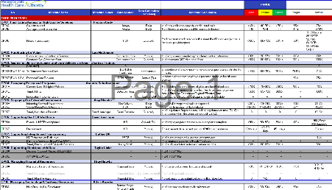
Track measures, definitions, target performance ranges and actual performance for QTRs.

HCA QTR completion rate by division
Division | Measure one | Measure two | Measure three
Office of the Director | 80% | 90% | 85%
Office of Audit and Accountability | 92% | 87% | 91%
Clinical Quality and Care Transformation | 88% | 82%

Learn more at https://inside.hca.wa.gov/our-hca/results-hca

